
Next steps and actions
My strengths to build on
People who can help me
Now

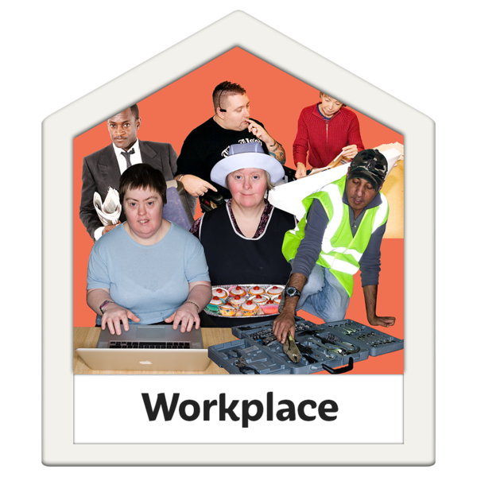
My Path to employment, education and training

My Dreams and Ambitions

