Operation Watershed Active Communities Fund
Information on the grant criteria and supporting documentation can be found on www.westsusex.gov.uk/watershed
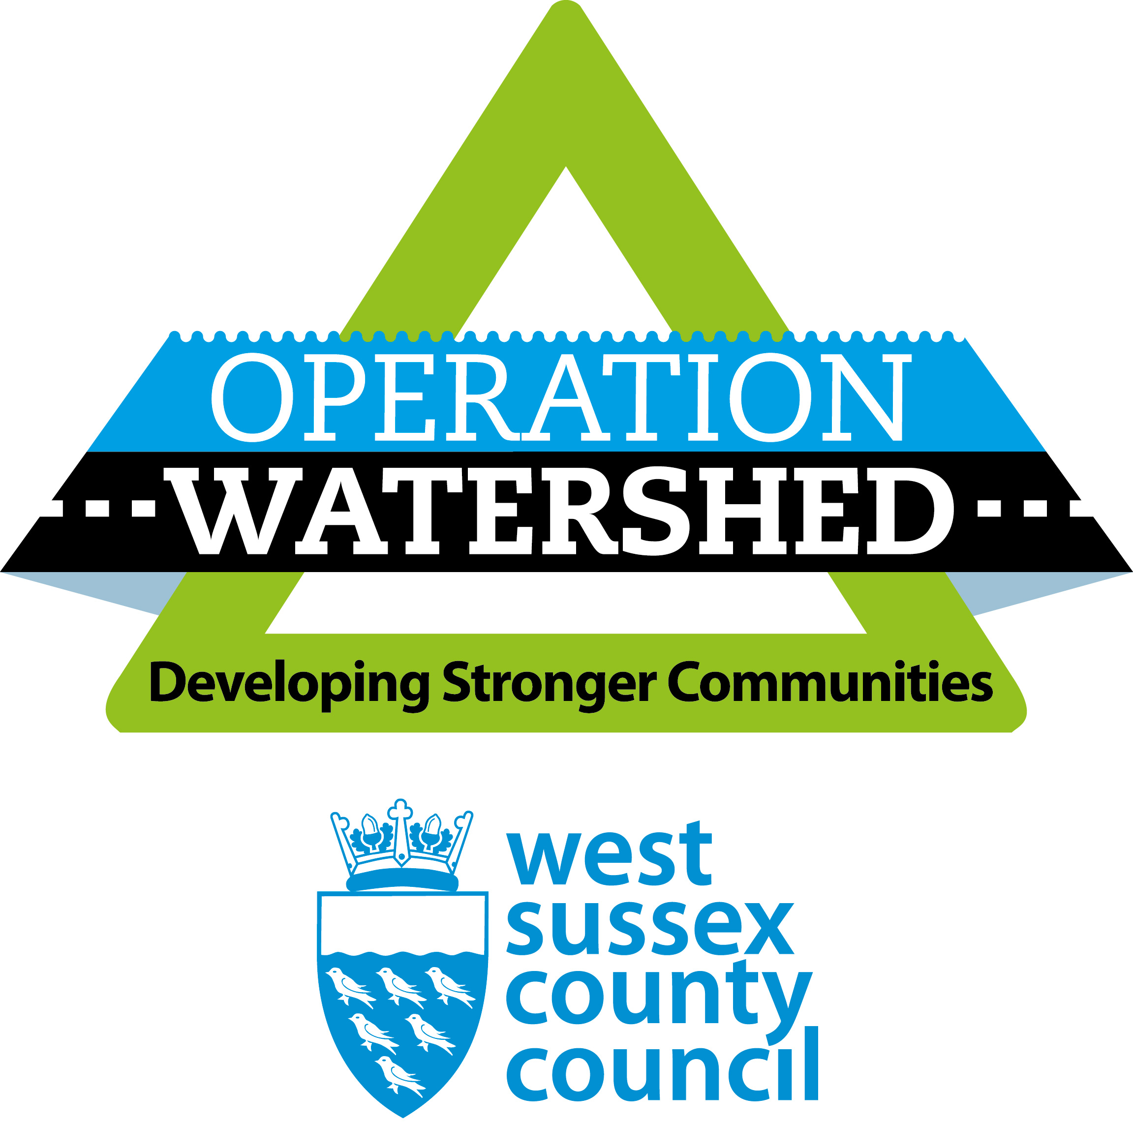
If your community has a project that may be eligible for funding, please complete the expression of interest form providing the following details so that Operation Watershed can consider if your project is eligible for the grant to consider.
Please send through any photos you have of the flooding along with the form.
We will contact you to discuss further
Expression of Interest
Section A: You and your community group
Community Group Name and charity/company number (if applicable:)
Parish name:
Name of WSCC County Councillor
Postal address
Postcode
Your name
Position
Daytime phone number
Email address

Section B: Brief information about your project
Location Details inc a map
Describe the issue:
- When it floods e.g heavy rain, prolonged rainfall, light/moderate rainfall.
- Frequency of flooding
What impact does the flooding have on the following:
Flooding Property (internal or grounds)
Other properties
Public Highway
Other etc
How long has flooding been an issue?
If it is highway flooding has it been reported and dealt with previously?
If flooding is related to private land including water coming from the private land, have you had discussions around the issue? – Any application relating to private land would require the applicant obtaining consent from the landowner and they may well need to maintain the new infrastructure on the land. This is something that can be discussed as the issue and scheme is better understood.
Do you require technical support to develop a scope to obtain quotes from contractors. | Y/N
If you have already identified a scheme, please provide brief description of proposed works or activity.
Have you spoken to anyone in the county council or your local county councillor about this in the past? (please give details)

