


What Happened?
Form
If someone hurts you or frightens you please tell someone so they can help you.

You can use this form to help you remember things and show it to the person who comes to talk to you.

Please fill in as much as you can.


What happened?
You can draw a picture or write some words here to say what happened.
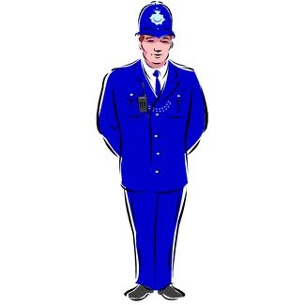
If you called the Police, please write down the serial number they gave you here:

2

Who did it?

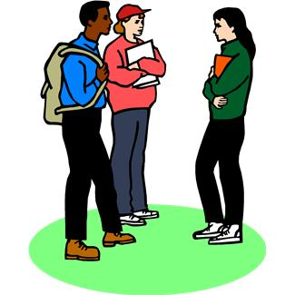
A man?
A woman?
A group of people?
Children?
Do you know them?
?


Did anyone see it?

Were you on your own?

Yes No
Were you with a friend?
If YES, what is their name?
Did anyone else see what happened?
If YES, what can you remember about them?
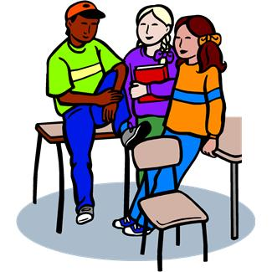

3




When did it happen?

Was it daytime?
What date?
Was it evening or night-time?
What was the time?
Where did it happen?

Inside at:

Outside at:

Has this sort of thing happened before?

Yes No

How many times?

here

4


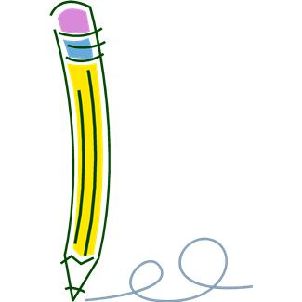




What is your name?
When is your birthday?
What is your phone number?
Who is your Community Support Worker or Social Worker?
Do you know their phone number?
This part is about you:

What is your address?

5

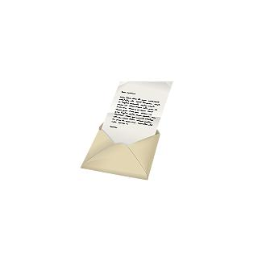
Would you like someone at Victim Support to talk to you?

Yes No

What happens next?

Please tell your Community Support Worker or Social Worker what has happened.

6
How would you like us to talk to you?
(Please tick a box to show how you would like us to talk to you)

Letter

Phone

In Person
Did someone help you fill this form in? If YES what is their name?



Please send this form to Victim Support in one of these ways:
POST to: Victim Support
PO Box 101
Crawley
RH10 8UA
EMAIL: SussexHateIncidentReport@victimsupport.org.uk

PHONE: 0845 3899 528
If you need this form in a larger print please contact the above address.

