School Organisation and Development Team
Ground Floor, Northleigh
County Hall Campus
Tower Street
Chichester
West Sussex
PO19 1RQ

Application Form

Free school presumption competition for a new all-through school with SEND and Early Years facilities to serve the Burgess Hill Northern Arc for Sept 2023

Early notice – we would welcome early notice from providers intending to submit an application. It will be strictly confidential and will help us with preparations for the remainder of this timeline if we know how many applications we may receive. Please send a brief email to schoolconsultations@westsussex.gov.uk. If you later choose not to apply please let us know.

The deadline for your completed form is 5pm on 12 October 2021 to
schoolconsultations@westsussex.gov.uk

We will send you an acknowledgement of receipt. If this is not received within 24 hours, please contact the team to confirm safe receipt.

NOTE – Applications should be no longer than 50 pages
(shorter submissions will not be penalised)

Section A – Applicant Details
Name of organisation.

Contact details (name, email address, phone number, and postal address).

How would you describe your organisation?

When did you become a DfE approved sponsor?

Do you currently run any existing schools, academies or free schools? If so, please give details, including the most recent Ofsted and attainment data for each.

Did you put this application together with support from another company or organisation? And if so, please provide details about this organisation.

Section B – The School

Please explain how your organisation’s knowledge and experience of the local area would be used to inform your plans to establish this particular school.

Section C – Vision
Please explain your vision and how it meets the requirements in the published specification.

Section D – Education Plan
Please explain how your educational offer/curriculum plan meets the requirements in the published specification.

Section E – Capacity and Capability
Please explain and provide evidence of how your organisation would meet the requirements in the published specification.

CONTACT US

Email: schoolconsultations@westsussex.gov.uk
Telephone: 0330 222 3046
Post: Burgess Hill Free School Competition
School Organisation and Development Team
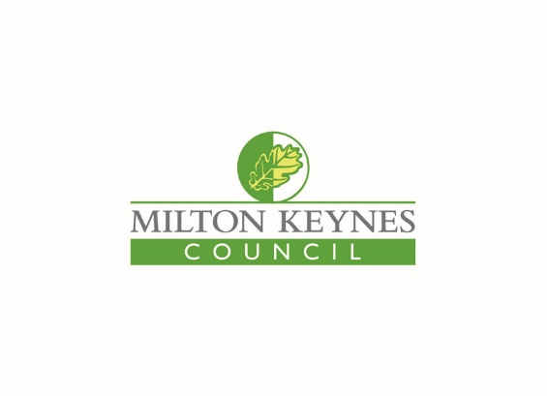
Ground Floor, Northleigh
County Hall Campus
Tower Street
Chichester
West Sussex
PO19 1RQ

NOTE – Applications should be no longer than 50 pages

Prepared: August 2021

