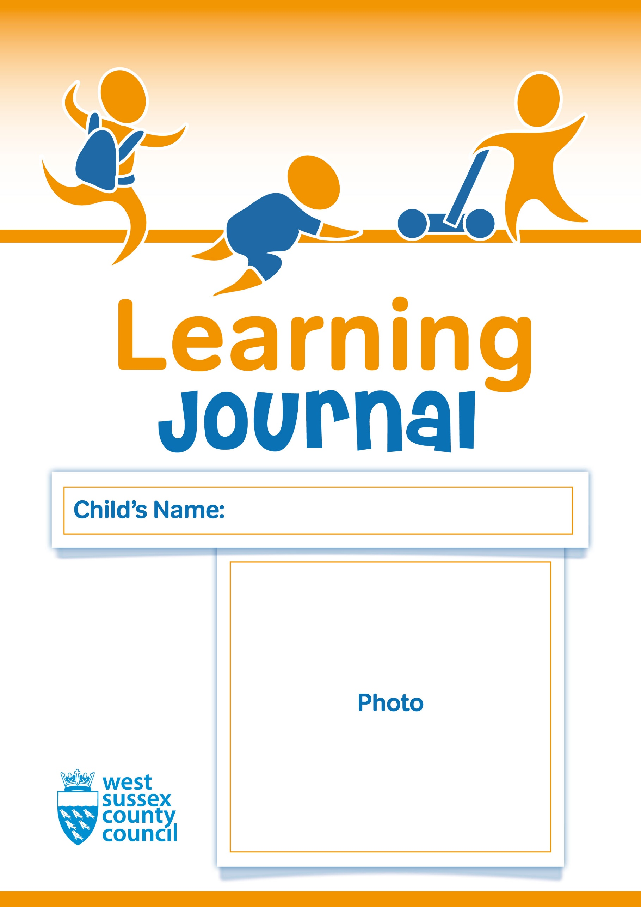

DATE: / /

ALL ABOUT ME

My favourite things at home are:

(This might include toys, games, comfort objects, stories, places …)

Meaningful or special relationships in my life are:

(This might include family members, friends, people who look after me, other people involved in my life, even pets! Photos are lovely to see and share – and it helps us to know who everyone is!)

ALL ABOUT ME

My routines are:

(This might include eating and sleeping routines, the kind of cup I use, my toileting habits, my routines, and who will usually bring and collect me.)

How I communicate:

(This might include special words or gestures, home language or any other types of communication I use.)

ALL ABOUT ME

My feelings:

(This might include what makes me happy, sad, angry or scared and how I show these feelings.)

When I am feeling … it helps me if …

ALL ABOUT ME

Anything else you might need to know about me:

(This might include any health care needs, other people who are involved in my well-being, or any other information I would like to share with you.)

ALL ABOUT ME

Ongoing observations and discussions:

2 Year Old Progress Check for _________________ Age_____ (in months) Date of 2 Year Health Check _______________

Characteristics of Effective Learning including engagement, motivation and thinking
Learning and Development summary
Personal, Social and Emotional | Communication and Language | Physical
Areas in which I am making progress

Areas where I need more support (including any areas where I am not yet at an expected level)

Together we will… (including who is responsible and review date)
Parent’s signature Key Person’s signature Date

Individual Progress Review and Planning for ____________________Age _____Months

Child’s Voice
Parent/Carers comments
Key Person comments
Characteristics of Effective Learning including how I engage in learning experiences, what motivates me and my thinking skills
Strengths and Interests
Any Worries
Parent’s signature Key Person’s signature Date

Individual Progress Review and Planning – Prime Areas of Learning

Name: Date of Birth:

Terms | Personal, Social and Emotional Development | Physical Development | Communication and Language
Term 1 -
Date:-

Strengths

Next steps

Term 2
Date:-

Strengths
Next Steps
Term 3
Date:-

Strengths

Next Steps

Individual Progress Review and Planning – Specific Areas of Learning

Terms | Literacy | Mathematics | Understanding the World | Expressive Arts & Design
Term 1 -
Date:-

Strengths

Next steps

Term 2
Date:-

Strengths
Next Steps
Term 3
Date:-

Strengths

Next Steps

